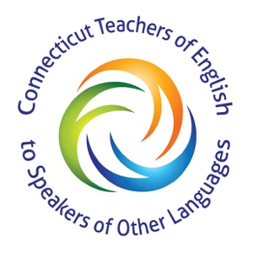

TO: ESL Directors and Teachers, Bilingual Directors and Guidance Personnel, and Students

FROM: Board Members of ConnTESOL

DATE: Friday, May 29, 2020

RE: ConnTESOL’s $1,000 Scholarship

This year ConnTESOL (Connecticut Teachers to Speakers of Other Languages) is again proud to announce that we will be awarding three $1,000.00 scholarships to high school seniors. ConnTESOL in conjunction with CAPELL (Connecticut Administrators of Programs for English Language Learners) is able to offer a third $1,000.00 award again this year. The awards will be given to a graduating high school senior, presently or previously enrolled in EL or Bilingual Education classes. We are looking for students planning to attend a four-year college or a community college in the fall of 2020.
The purpose of this award is to encourage EL and Bilingual Program students to expand their horizons, define their dreams and attend college. Please encourage students to apply. Feel free to make copies of the enclosed packet if you have more than one candidate. Be advised that only the requested documentation will be reviewed.
The deadline for receiving completed applications is September 30, 2020. Scholarship winners will be announced at our fall conference. It is our hope that the winners, their families and their teachers will be able to attend the awards ceremony at our fall conference. The money will be available upon receipt of the student’s proof of enrollment for the Spring 2021 semester. Winning essays will be published in ConnTESOL’s website.

PLEASE RETURN ONLY COMPLETE APPLICATION PACKETS TO: Scholarships@ConnTESOL.org or contact us at (203) 556-3941 with your questions.

Thank you for your cooperation and good luck to your applicants.

Sincerely,
Board Members
www.ConnTESOL.org
Scholarships@ConnTESOL.org

Connecticut TESOL High School Scholarship Application

Dear Applicant,
This is your application for the Connecticut TESOL Scholarship. Please complete all the information on the following pages. Then write a 250 to 500 word essay on the following topic:

“A different language is a different vision of life.” (Federico Fellini)

Explain how your learning English has influenced your life and your future plans.

The composition must be typed.

Select one teacher whom you know well and ask him/her to write you a letter of reference (there is no specific form for this letter, a personal letter is fine). Give the guidance office form to your guidance counselor or administrator to fill out. Then return everything to the scholarship committee chairperson.

- All information requested must be included:
  - application form
  - guidance office form
  - essay
  - letter of recommendation
- All information must be returned in one packet
- Return packets by September 30, 2020

DO NOT send high school transcripts.

PLEASE RETURN ONLY COMPLETE APPLICATION PACKETS TO: Scholarships@ConnTESOL.org or contact us at (203) 556-3941 with your questions.

Thanks for your cooperation and good luck.

Sincerely,
Board Members
www.ConnTESOL.org
Scholarships@ConnTESOL.org
Scholarships@ConnTESOL.org | High School Scholarship Application
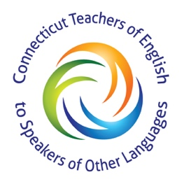

Applicant Information
Full Name: |  |  |  | Date:
 | Last | First | M.I.

Address:
 | Street Address | Apartment/Unit #

 | City | State | ZIP Code

Phone: |  | Email

Education
School Attending Now: |  | Your First Language:

What English Learning Program were you enrolled in? ELL Bilingual Other: ___________________
How many grades or years were you in that language learning program? |  | Years in USA?

ACTIVITIES
Describe any jobs, activities or clubs that you have participated in, inside or outside of school and any officer’s position that you have held. Include also any honors you have received.

Disclaimer and Signature
I certify that my answers are true and complete to the best of my knowledge.

Signature: |  | Date:

Scholarships@ConnTESOL.org | ConnTESOL High School Scholarship Guidance or Administrative Office Form
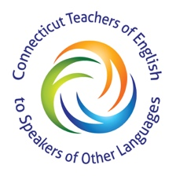

Applicant Information

Student’s  Full Name: |  |  |  | Date:
 | Last | First | M.I.
School Name:

School Address:

Street Address

 | City | State | ZIP Code

Education
Grade Point Average (GPA) or ranking: |  | Is the student applying for a 2 or 4 year degree?

To which post-secondary schools has this student applied?
To date, please indicate to which schools this student been accepted?

Guidance Counselor or Administrator

Name of the Guidance Counselor or Administrator: |  | Date:

Best Contact Number:

END

Do not include transcripts. ONLY the requested documentation will be reviewed.
Please return entire completed packet by September 30, 2020.

