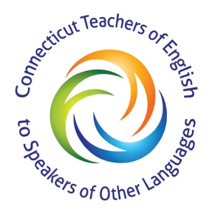

TO: Adult Education Directors and ESOL Teachers and Students

FROM: Board Members of ConnTESOL

DATE: Friday, May 29, 2020

RE: ConnTESOL’s $1,000 Scholarship

ConnTESOL (Connecticut Teachers to Speakers of Other Languages) will again be awarding a $1,000.00 scholarship to an adult education student currently enrolled in an ESL or adult education class whose first language is not English and is planning to enroll in a higher education program in the fall.
The purpose of this award is to encourage English Language Learners to expand their horizons, define their dreams and attend college. Please encourage students to apply. If you have more than one applicant, please feel free to make copies of the enclosed packet. Be advised that only the requested documentation will be reviewed.
The deadline for receiving completed applications will be September 30, 2020. It is our hope that the winners, their families, and teachers will be able to attend the award ceremony at our fall conference. The money will be available upon receipt of the student’s proof of enrollment for the Spring 2021 semester. Winning essays will be published in ConnTESOL’s website.

PLEASE RETURN ONLY COMPLETE APPLICATION PACKETS TO: Scholarships@ConnTESOL.org or contact us at (203) 556-3941 with your questions.

Thank you for your cooperation and good luck to your applicants.

Sincerely,
Board Members
www.ConnTESOL.org
Scholarships@ConnTESOL.org

Connecticut TESOL Adult Education Scholarship Application

Dear Applicant,
ConnTESOL (Connecticut Teachers to Speakers of Other Languages) will again be awarding a $1,000.00 scholarship to an adult education student currently enrolled in an ESL or adult education class whose first language is not English and is planning to enroll in a higher education program in the fall.
The purpose of this award is to encourage English Language Learners to expand their horizons, define their dreams and to further their education.
The application for the Connecticut TESOL Scholarship has three components: an information form, an essay, and a reference letter. Please complete all the information and return all three parts to ConnTESOL.
The essay topic is: “A different language is a different vision of life.” (Federico Fellini) Explain how learning English has influenced your life and your future plans. This 250 – 500 word essay must be typed. Winning essays will be published on the ConnTESOL website and in our newsletter.
Select one teacher whom you know well and ask him/her to write you a short reference letter. There is no reference letter form included in this packet. A personal letter is fine.

Important:

- All information requested must be included:
  - application form
  - essay
  - letter of recommendation
- All information must be returned in one packet
- Return packets by September 30, 2020

PLEASE RETURN ONLY COMPLETE APPLICATION PACKETS TO: Scholarships@ConnTESOL.org or contact us at (203) 556-3941 with your questions.

Thanks for your cooperation and good luck.

Sincerely,
Board Members
www.ConnTESOL.org
Scholarships@ConnTESOL.org
Scholarships@ConnTESOL.org | High School Scholarship Application
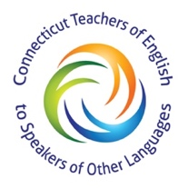

Applicant Information
Full Name: |  |  |  | Date:
 | Last | First | M.I.

Address:
 | Street Address | Apartment/Unit #

 | City | State | ZIP Code

Phone: |  | Email

Education
School Attending Now: |  | Your First Language:

College(s) that you plan to attend:
Field of study that you plan to study:
Current Occupation: |  |  |  | Years Studying English:

YOU and FAMILY
Describe any jobs you held, activities, community service, or clubs that you have participated in:

Please list any dependents and their ages

Disclaimer and Signature
I certify that my answers are true and complete to the best of my knowledge.
Signature: |  | Date:

